**CHAPTER ONE**

**INTRODUCTION**

## **Background**

Summer project is the field and practical based Learning. It is a platform to implement learning and knowledge of all the theoretical courses. It is a platform which helps us to realize about the how the lesson learned in the study course can be applied into practical field. Summer project involves field visit, data collection, data analysis and interpretation. Summer project helps to know about the real life working scenario. It helps to understand about the qualitative data and information used in the organization. The candidate can be well prepared for the internship program. It is an opportunity to grow our network and public relation. It helps to develop critical thinking to solve any problem. Therefore, it is the most important for the students to work on this project for the self-development of communication skill and experiencing the working environment.

The objective of the SP is to enable students to study organization (or unit of organization), analyze the situation (past, present) and report the study. Students should be able to provide their own suggestions/solutions to the issues/problems in the existing situation of the organization if they found any.

The **Travel Booking System** is automated and makes the travelling activities much easier and flexible and is based on a visit to the respective organization (Lumbini Peace Travels and Tours Pvt. Ltd). The user can get very right information at the very right time. Customers can get the knowledge of the packages containing the price, travelling ways, and reservation in their trip prior to their starting of the trip. This will increase the trust if the customer into the travel company.This system is a web based application and maintains a centralized repository of all related information. The system allows one to easily access the relevant information and make necessary travel arrangements. Users can decide about places they want to visit and make bookings online for travel and accommodation.

**1.2 Introduction of the organization**

**1.2.1 Introduction**

Lumbini Peace Travels and Tours Pvt. Ltd. is the company up of professional team members.It was established in 2012 and is located in New Road, Kathmandu, Nepal. Lumbini Peace Travels and Tours Pvt. Ltd. is government registered Travel and Tours Company. It has strong management team which is always in service to clients to give quality service in reasonable price is the motto. It have highly experienced and knowledgeable travel and tour guides who can explain in detail about the culture, history, nature, religion, geography and way of life about the places. It ensures clients successful travel and tour in the every corner of Nepal. It has always committed to provide quality services and heartily accept and immediately implement the suggestions given by their clients.

**1.2.2 Objectives**

* To provide detail information about travelling and tours.
* To provide services at a competitive price making a small profit for employees and the local people in the communities we visit.
* To promote, stimulate and promote travel.
* To offer expertise and experience to the clients and work to ensure the highest environmental, ethical standards.
* To offers excellence quality, service and security.
* To act as a liaison between the travel agents, tourism suppliers and government agencies on issues and matters of concern.
* To ensure safe and best travel memories to the clients.

**1.2.3 Mission**

Tourism is the building block of national economy. It is not just an integral part of the economy but greatly influences overall activities. The mission of Lumbini Peace Travels and Tours is “Motivating domestic and international tourists to travel in every part of the country and guiding them on the right track to realize those destinations”.

**1.2.4 Vision**

Lumbini Peace Travels and Tours continuously strive to increase the number of tourist travelling in different parts of the country by providing satisfactory and easy services to travelers. The company aims to create a network with international travel agencies to make their service broad. The vision of the company is to satisfy through satisfactory and prompt services.

**1.3 Current situation of the organization**

Up to now Lumbini Peace Travels and Tours is dealing with management of customers who come to organization and provide the facilities of booking and travelling. As per the present situation of the organization, they are using manual record and phone call system. They want to some changes in their recording which would be dependable, usable, and reliable, secured and can be used for long term purpose.

**1.4 Structure of the Organization**

Organizational structure is a system used to define a hierarchy within an organization. It identifies each job, its functions and where it reports to within the organization. This organization also has its own organizational structure. The hierarchical structure practiced in is as follows:

Managing Director

Account Department

Operating Department

Accountant

Receptionist

Computer Operator

Tour Guides

Fig 1.4: Hierarchy of organization

**1.5 Problem Definition**

The works are to be done manually through phone calls. The details are available in the website but booking is to be done through phone calls and query emails.In the present system a customer has to approach various agencies to find details of places and to book tickets. This often requires a lot of time and effort. A customer may not get the desired information from these offices and often the customer may be misguided. It is tedious for a customer to plan a particular journey and have it executed properly.

**1.6 Objective of the Project**

With the large number of work opportunities the human workforce has increased. There is a need of a system which can handle the data in efficient, convenient and safe way. The project is done under different objectives. There are some of the general and specific objectives which are mentioned as follows:

1. **General Objective**

The basic purpose of this project is to develop a system that automates the processes and activities of a travel and the purpose is to design a system using which one can perform all operations related to traveling.

1. **Specific Objective**

The specific objectives of this project are mentioned below:

* To make the manual work electronic based
* To upgrade the existing system of the organization
* To complete the future plans of the organization
* To make faster processing time and more accurate data for travel requests and reimbursements

**1.7 Methodology**

Research methodology is the process of arriving to the situation of the problem through planed and systematic dealing with the collection, analysis and interpretation of facts and figures.

**1.7.1 Project Framework**

Project framework is a combination of processes, tasks, and tools used to transition a project from start to finish. Each stage of this process involves the completion of many tasks using various tools.

Figure 1.1: Project Framework

* **Project Initiation:** The **Project Initiation Phase** is the 1st phase in theProject Management Life Cycle*,* as it involves starting up a new project. In this phase, new project is started by defining its objectives, scope, purpose of the report and the proposal was submitted to state the clear information about the organization, their location, objectives, the existing problem and effective recommendation as per the information provided by the concerned person. For further details, the organization was visited. After the approval of the proposal defense, the next phase is started.
* **Project Planning:** The **Project planning** is a discipline for stating how to complete a project within a certain timeframe, usually with defined stages, and with designated resources. The time frame thatwas estimated for the data collection and organization visit was 3 days.
* **Project Execution:** The **Project Execution Phase** is the third phase in the project life cycle. In this phase, you will prepare a questionnairerelated with the concerned topic and present them to employees for their response. Beside the questionnaire approach; interview was also taken with the managing director of the company to know about the working scenario and activities performed by the organization**.** The details were recorded in the paper The Project Execution Phase is usually the longest phase in the project life cycle and it typically consumes the most energy, time and the most resources.
* **Project Closure:** The **Project Closure Phase** is the fourth and last phase in the project life cycle. In this phase, we will formally close our project and then report the overall level of success and findings to our mentor. Project Closure involves handing over the deliverables and passing the documentation including all the activities from the scratch level to the completion of the project to the concerned External teachers and presented them visually by using PowerPoint.

**1.7.2 Nature and Source of data**

There are basically two types of nature and sources of the data. They are described as follows:

1. **Primary Source:** Primary source include observation, survey, interview and questionnaires. Interview with directing manager have helped to fetch huge amount of information regarding the current scenario, problems and future of the organization. Discussions with different personnel from different department were undergone and hence observation was made.
2. **Secondary Source:** The secondary sources used while completing this report was different websites and internet.

**1.7.3 Data and Information**

It involves all the data and information were collected and found during the overall summer project. The data and information that we are collected can be presented and analyzed in quantitative as well as qualitative terms. It is the core part of the report where we understand the issue of the firm, current situation of firm, current activities of the firm and the possible solutions of the issue.

Here, various tools and techniques are used like statistical tools such as ratio analysis, correlation analysis, regression analysis, profitability analysis etc. or can also use qualitative tools and the best way is to combine both the qualitative and quantitative tools. The detail analysis of data and information is presented in "chapter two".

**1.7.4 Tools used**

During this development of this report different tools are used. Mainly used tools are as follows:

* **Microsoft word for documentation**

The Microsoft word document is used for softcopy documentation of the project. All the document design and numerations are done by using Microsoft word document version 2016.Microsoft word document application is widely used application for the documentation purpose for its reliability and user friendliness.

* **Firefox /Google Chrome as browser**

Firefox and Google Chrome are used to run the system. Mainly Google Chrome is used to run the local host installed in the computer. As a browser Google Chrome is used to run the developed system and collection of information and researches through different websites.

* **Sublime Text**

Sublime Text is a proprietary cross-platform source code editor. It is used for editing the text code.

* **Xampp Server**

Xampp is the authorized platform to run PHP applications as well as MySQLapplications. For development of this system, Xampp is used to create database through PHP my admin as well as PHP file and web pages.

**CHAPTER TWO**

**TASK AND ACTIVITIES PERFORMED**

* 1. **Analysis of Task and Activities**

**2.1.1 Organization Selection**

The main purpose of this summer project is to connect my theoretical knowledge to practical scenario which was guided by the knowledge and skills that I have gained in programming in past few years. Summer Project is a program that provides student an exposure to the professional world. Among the various options and criteria’s provided by TU to work in, web based programming language PHP was chosen among them. Among the various organizations shortlisted, I choose Lumbini Peace Travels and Tours Pvt. Ltd. based on the environment of the organization and to understand the technical aspect of real world scenario regarding the organization.

**2.1.2 Analysis of past and present situation of the organization**

In existing systems, the works are to be done manually through phone calls. The details are available in the website but booki0ng is to be done through phone calls and query emails.In the present system a customer has to approach various agencies to find details of places and to book tickets. This often requires a lot of time and effort. A customer may not get the desired information from these offices and often the customer may be misguided. It is tedious for a customer to plan a particular journey and have it executed properly.

If the organization use this system, they can effectively manage the booking and also able to overcome the faults of the manual system. This system is easier to use, convenient, faster, accurate and time saving. **Travel Booking System** records the information about users who have booked for travelling, available tour package, etc. The users simply can login to the website and fulfill their information to a form for any query and can further sign up for bookings and other additional citations. The record is stored in the database.

**2.1.3 Problem Identification**

The first step in the problem solving and decision making process is to identify and define the problem. A problem can be regarded as a difference between the actual situation and the desired situation. The major aim of this project is to design a travel booking system inside the webpage of the organization. There used to be a website but was not into maintenance and frequent updates.

The organization is facing certain problems. The main problem of this organization is implementation is traditional booking system. As the world becomes more digital in nature, and ever growing issue for the records management group is the conversion of existing or incoming paper records to electronic forms. Privacy and data protection are increasing issues in an organization.

The need to ensure personal information is not retaining unnecessarily has brought greater focus to retention schedules and records disposal. Similarly the adaptation and implementation is another major issue. Implementing required changes to organizational culture is a major challenge; the business is being more competitive. Every other similar organization has been adopting the electronic booking system. Conversion of paper record to computerized form has been emerging issue to adapt in the business environment.

**2.2 Feasibility Study**

A feasibility study is an analysis of how successfully a project can be completed, accounting for factors that affect it such as economic, technological, legal and scheduling factors. It shows how the system is associated with the business strategy. The categories within the feasibility study that need to be discussed are economic and technical feasibility.

**2.2.1 Technical Feasibility**

The technical issue usually raised during the feasibility stage of the investigation includes the following:

* Does the necessary technology exist to do what is suggested?
* Do the proposed equipment have the technical capacity to hold the data required to use the new system?
* Will the proposed system provide adequate response to inquiries, regardless of the number or location of users?
* Can the system be upgraded if developed?
* Are there technical guarantees of accuracy, reliability, ease of access and data security?

Earlier no system existed to cater to the needs of ‘Travel Booking System’. The current system developed is technically feasible. It is a web based user interface. Thus it provides an easy access to the users. The database’s purpose is to create, establish and maintain a workflow among various entities in order to facilitate all concerned users in their various capacities or roles. Permission to the users would be granted based on the roles specified.   Therefore, it provides the technical guarantee of accuracy, reliability and security. The software and hard requirements for the development of this project are not many and are already available as free as open source. Programming languages and Databases such as PHP, MYSQL are open source. They are all available to the public.

**2.2.2 Economic Feasibility**

A system can be developed technically and that will be used if installed must still be a good investment for the organization. In the economical feasibility, the development cost in creating the system is evaluated against the ultimate benefit derived from the new systems. Financial benefits must equal or exceed the costs.

The system is economically feasible. It does not require any addition hardware or software. Since the interface for this system is developed using the existing resources and technologies available at the organization, there is nominal expenditure and economical feasibility for certain.

**2.2.3Operational Feasibility**

Proposed projects are beneficial only if they can be turned out into information system. That will meet the organization’s operating requirements. Operational feasibility aspects of the project are to be taken as an important part of the project implementation. Some of the important issues raised are to test the operational feasibility of a project includes the following: -

* Is there sufficient support for the management from the users?
* Will the system be used and work properly if it is being developed and implemented?
* Will there be any resistance from the user that will undermine the possible application benefits?

This system is targeted to be in accordance with the above-mentioned issues. Beforehand, the management issues and user requirements have been taken into consideration. So there is no question of resistance from the users that can undermine the possible application benefits. The well-planned design would ensure the optimal utilization of the computer resources and would help in the improvement of performance status.

**2.3 Requirement Analysis and Specification**

It is the process of gathering the information about the required and existing systems and distilling the user and system requirements from this information. Requirement Specification involves Functional Requirement and Non-Functional Requirement.

**2.3.1 Functional Requirements**

A function is described as a set of inputs, the behavior, and outputs. **Functional requirements** may be calculations, technical details, data manipulation and processing and other specific functionality that define what a system is supposed to accomplish. The functional requirements of the **Travel Booking System** are cited below:

* The system supports customers booking and able to modify them.
* The customers can view the tour packages and the detail information.
* Customers can cancel their booking from their account.
* Admin able to confirm/cancel customers booking information.

**2.3.2 Non-Functional Requirements**

A non-functional requirement (NFR) is a requirement that specifies criteria that can be used to judge the operation of a system, rather than specific behaviors. They are contrasted with functional requirements that define specific behavior or functions. The non-functional requirements of the **Travel Booking System** are cited below:

* All the pages should load within three seconds.
* System should be able to handle multiple users at a time.
* All the passwords should be encrypted.

**2.4 System Design**

Design is the process of implementing software solutions to one or more sets of problems. One of the main components of software design is the software requirement analysis. Different design mechanisms are used for implementation during the system development.

**2.4.1 System Flowchart**

A flowchart is a type of diagram that represents an algorithm, workflow or process, showing the steps as boxes of various kinds, and their order by connecting them with arrows. This diagrammatic representation illustrates a solution model to a given problem.

Is Member?

Registration

Login

Is Valid?

Admin

Customer

Manage user

View Package

Manage Package

Book Package

Manage Booking

Manage Tour

View Feedback

Give Feedback

Logout

No

Yes

No

Yes

Yes

No

Figure 2.1: System Flowchart

**2.4.2 UML Diagram**

UML stands for Unified Modeling Language. It's a rich language to model software solutions, application structures, and system behavior and business processes.

**a) Use Case Diagram for Admin**

**ADMIN**

Figure 2.2: Use Case Diagram for Admin

**b) Use Case Diagram for User**

**USER**

Figure 2.3: Use Case Diagram for User

**2.5 Implementation**

Implementation is the carrying out, execution or practice of a plan, a method or any design, idea, model, specification, standard or policy for doing something. As such, implementation is the action that must flow any preliminary thinking in order for something to actually happen. The design made on earlier phase was implemented in to a functional system using HTML, PHP, JavaScript, and Bootstrap framework. The design is implemented in four parts; Home page, Contact page, Tour Packages and Account page. Some screenshots along with the description are cited below:

**Home Page**

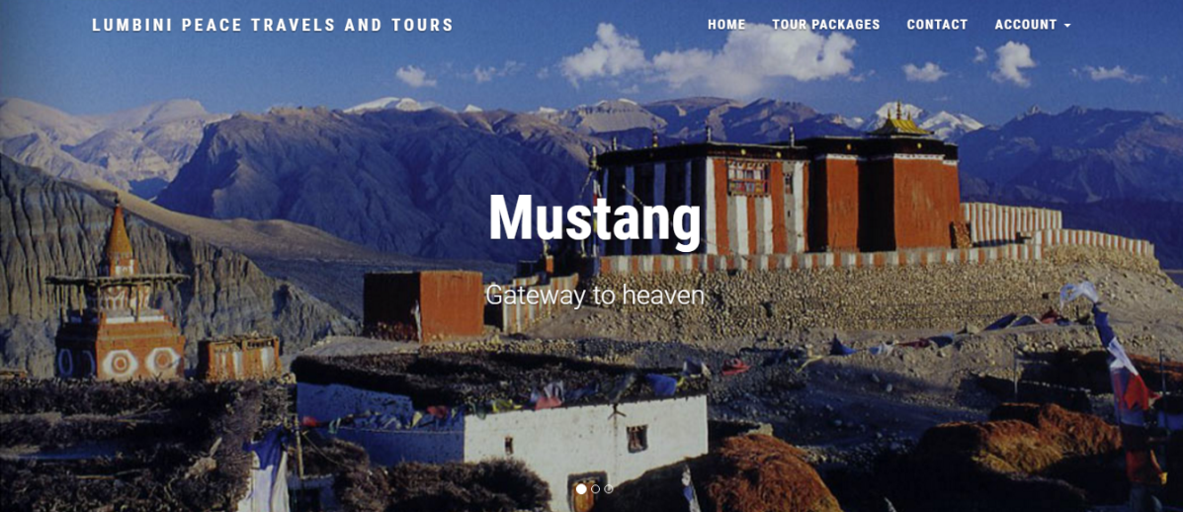

**Home Page** of the web site which is the very first page of the website the user see after entering the website of the organization.

**Contact Us page**

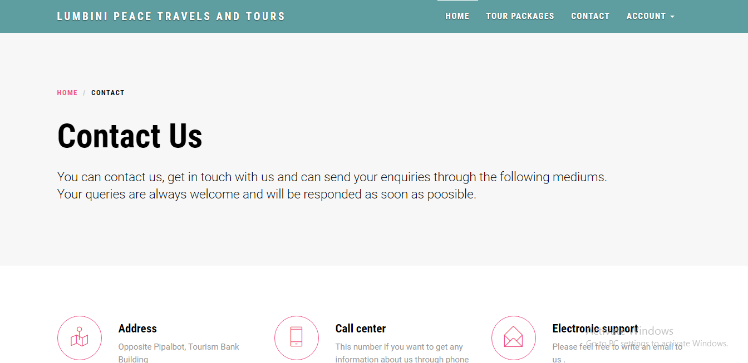

Similarly the **Contact Page** where the user can get details about the contact methods to get in touch. Further screenshots of the modules are cited in “Appendices”.

**Login Page**

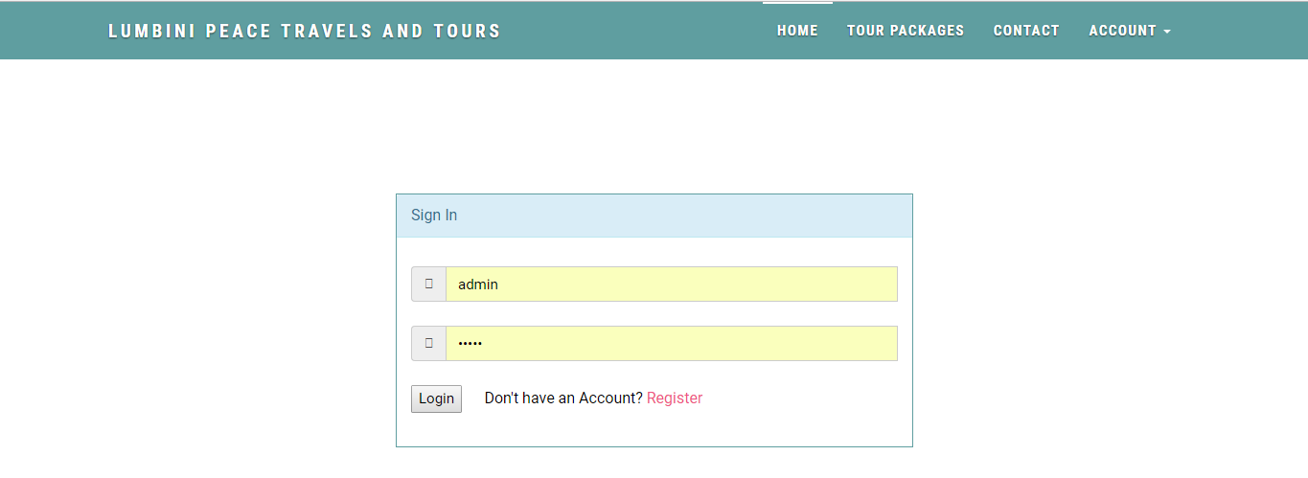

This is the login page where the users login and are authorized for further access.

**2.6 System Testing and Validation**

**2.6.1 System Testing**

System Testing is a level of the software testing where complete and integrated software is tested. The purpose of this test is to evaluate the system's compliance with the specified requirements.

**2.6.1.1 Unit Testing**

This is the testing process which we can do manually because in this testing program is a tested individually using dummy record to see whether that program produce satisfied output as the company and validation also.

**2.6.1.2 Validation Testing**

In this requirements established as part of software requirements analysisare validated against the software that has been constructed.Validation can be define in many ways but a simple definition is that validation succeeds when software Function in a manner that can be reasonably by the customer.

**2.6.1.3 Test Cases**

|  |  |  |  |  |  |
| --- | --- | --- | --- | --- | --- |
| Admin Cases: | | | | | |
| Case Id | Test Case | Expected Output | Actual Output | Pass/Fail | Remarks |
| 01 | Login Test | Login with proper details. | Success | Pass | Good |
| 02 | Managing Users | Retrieve and manage user information properly | Success | Pass | Good |
| 03 | Add/Update Packages | Add and update package properly. | Success | Pass | Good |
| 04 | Manage Feedback | Retrieve and manage user feedbacks. | Success | Pass | Good |

Table 2.1: Admin Test Cases

|  |  |  |  |  |  |
| --- | --- | --- | --- | --- | --- |
| User Cases: | | | | | |
| Case Id | Test Case | Expected Output | Actual Output | Pass/Fail | Remarks |
| 01 | Login Test | Login with proper details. | Success | Pass | Good |
| 02 | Registration Test | Proper registration with validation. | Success | Pass | Good |
| 03 | View Packages | Retrieve package information properly. | Success | Pass | Good |
| 04 | Book Packages | Book packages with proper information and validation. | Success | Pass | Good |
| 05 | Maintain Tour History | Retrieve tour history information. | Success | Pass | Good |

Table 2.2: User Test Cases

**2.6.2 System Validation**

System Validation is a set of actions used to check the compliance of any element (a system element, asystem, a document, a service, a task, a systemrequirement, etc.) with its purpose and functions.

**2.6.2.1 Client-side Validation**

Various client side validations are used to ensure on the client side that only valid data is entered. Client side validation saves server time and load to handle invalid data. Some checks imposed are:

* Forms cannot be submitted without filling up the mandatory data so that manual mistakes of submitting empty fields that are mandatory can be sorted out at the client side to save the server time and load.
* Tab-indexes are set according to the need and taking into account the ease of user while working with the system.

**2.6.2.2 Server-side Validation**

Some checks cannot be applied at client side. Server side checks are necessary to save the system from failing and intimating the user that some invalid operation has been performed or the performed operation is restricted. Some of the server side checks imposed is:

* User is intimating through appropriate messages about the successful operations or exceptions occurring at server side.
* Various Access Control Mechanisms have been built so that one user may not agitate upon another. Access permissions to various types of users are controlled according to the organizational structure. Only permitted users can log on to the system and can have access according to their category. User- name, passwords and permissions are controlled o the server side.
* Using server side validation, constraints on several restricted operations are imposed.

**CHAPTER THREE**

**DISCUSSIONS AND CONCLUSIONS**

**3.1 Major Findings**

During the preparation and after the completion of any project, we can get information about the field of study. Thusafter completion of this project I got to know about travel agencies, how they operate, how is the organizational structure and what are the information technologies that are being used in the organization, their present as well as past and the status of technology in travel agency and field of improvement in the behalf of the technology.

Nowadays technology is being widely used but not in satisfactory range. The system used by organizations is not up to date and are not able to provide service through the use of technology to the customers. Improvement is to be made in technologies being used. The **Travel Booking System** is web based application which can help the organization to compete and adopt in the trending business market. Other relative organization also can adopt such system for their simplicity and efficiency.

**3.2 Discussion and Conclusion**

This project proved good for me as it provided practical knowledge of not only programming in PHP and MYSQL web based application and no some extent of using open source frameworks for designing web applications, but also about all handling procedure related with project management. It also provides knowledge about the latest technology used in developing web enabled application and client server technology that will be great demand in future. This will provide better opportunities and guidance in future in developing projects independently.

This projects main aim was to convert the manual system of booking the tour and its records in “Lumbini Peace Travels and Tours” into a computerized system. Being through different difficulties and overcoming those difficulties with the help from the different persons and other different media this project has been successfully completed.

Despite the challenges and problems, the project was completed in specified duration. The system was tested by me as a developer and by some other person indirectly involved in the project. The project is finally obtained to implement a Travel Booking System in Lumbini Peace Travels and Tours in a computerized way.

**3.3 Future Enhancements**

Though the project has been able to justify the objective of the study and research, there are still many rooms for the system to be enhanced in future. Following enhancements can be adopted:

* This System being web-based and an undertaking of Cyber Security Division, needs to be thoroughly tested to find out any security gaps.
* Development and launching of Mobile app and refining existing services and adding more service.
* More interactive user interface can be designed.
* Features of online payment can be added.
* Loyal customers can be given special offers and discounts.

**Bibliography**

* <https://www.scribd.com/document/298729973/Tour-Travel-Management-System#user-util-view-profile>
* <http://ignousupport.blogspot.in/p/tours-and-travel-management-system.html>
* <https://yuml.me/>

**Appendices**

**Questionnaire**

1. Does the organization use any kind of desktop, mobile or webreservation system or not?
2. How the booking for a particular tour is done?
3. Are you looking forward for an electronic system?
4. What are the drawbacks of the current system?
5. What are the future plans of the system?

**Screenshots**

Home page showing travel packages

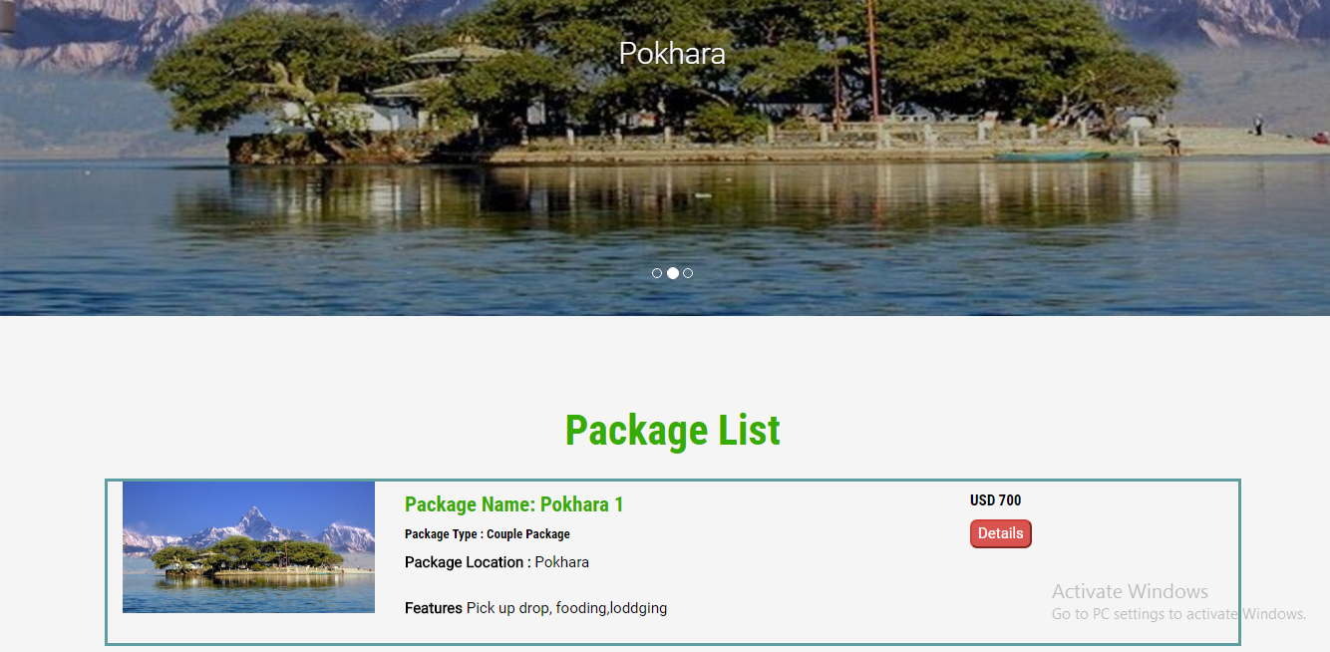

Login Page for Users



Registration Page for Users

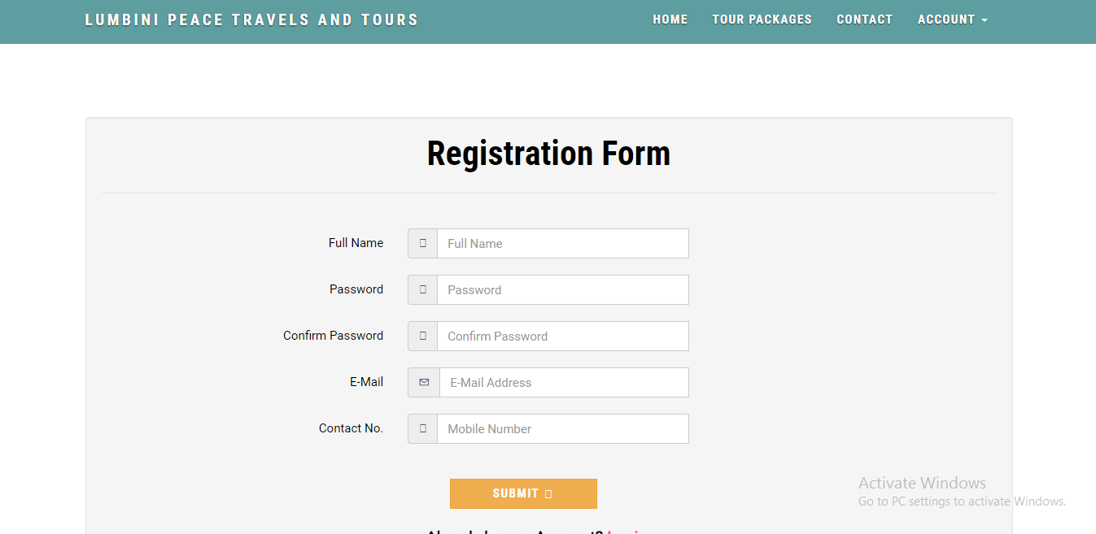

Package creation inside Admin’s Dashboard

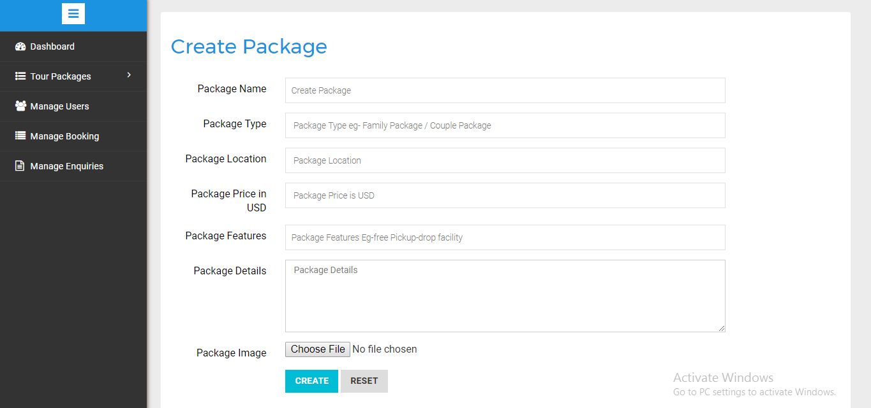

Booking Management inside Admin’s Dashboard

